**A PROJECT REPORT ON**

**DETECTING CYBERBULLYING IN SOCIAL MEDIA USING TEXT ANALYSIS AND ENSEMBLE TECHNIQUES**

***Major project submitted in partial fulfillment of the requirements for the***

***award of the degree of***

**BACHELOR OF TECHNOLOGY**

**IN**

**INFORMATION TECHNOLOGY**

**(2020-2024)**

**BY**

**V. ROHITH REDDY 20241A12H8**

**P. VAMSHI KRISHNA 20241A12G3**

**K. JASWANTH 20241A12E2**

***Under the Esteemed guidance***

***Of***

**Dr. Y. Jeevan Nagendra Kumar**

**Professor and Dean TIC**

**HOD Dept of IT.**



**DEPARTMENT OF INFORMATION TECHNOLOGY**

**GOKARAJU RANGARAJU INSTITUTE OF ENGINEERING AND TECHNOLOGY, HYDERABAD(AUTONOMOUS)**



***CERTIFICATE***

This is to certify that it is a bonafide record of Major Project work entitled **“**DETECTING CYBERBULLYING IN SOCIAL MEDIA USING TEXT ANALYSIS AND ENSEMBLE TECHNIQUES**”** done by **V.ROHITH REDDY(20241A12H8), P.VAMSHI KRISHNA(20241A12G3),K.JASWANTH(20241A12E2)** of **B.Tech (IT)** in the Department of Information Technology, **Gokaraju Rangaraju Institute of Engineering and Technology** during the period 2020-2024 in the partial fulfillment of the requirements for the award of degree of **BACHELOR OF TECHNOLOGY IN INFORMATION TECHNOLOGY** from GRIET, Hyderabad.

**Dr. Y.J. Nagendra Kumar Dr. Y. J. Nagendra Kumar**

**Professor Head of the Department**

**(Internal project guide)**

**(Project External)**

**ACKNOWLEDGEMENT**

We take immense pleasure in expressing gratitude to our Internal guide**, Dr. Y.J. Nagendra Kumar, Professor, Dept. of IT**, GRIET. We express our sincere thanks for his encouragement, suggestions and support, which provided the impetus and paved the way for the successful completion of the project work.

We wish to express our gratitude to **Dr. Y. J. Nagendra Kumar HOD** IT**,** our

Project Coordinators, Dr. G. Vijendar Reddy,L. Sukanya and Y. Subbaraidu for their constant support during the project.

We express our sincere thanks to **Dr. Jandhyala N Murthy,** Director, GRIET**,** and **Dr. J. Praveen,** Principal, GRIET**,** for providing us the conductive environment for carrying through our academic schedules and project with ease. We also take this opportunity to convey our sincere thanks to the teaching and non-teaching staff of GRIET College, Hyderabad.

 

Name: V. Rohith Reddy Name: P. Vamshi Krishna

Email:vanapatlarohith95@gmail.com Email:pinamonivamshikrishna@gmail.com

Contact:9491487430 Contact:7386653426



Name: K. Jaswanth

Email: [kandukurijaswanth2@gmail.com](mailto:kandukurijaswanth2@gmail.com)

Contact:8096656189

**DECLARATION**

This is to certify that the project entitled “DETECTING CYBERBULLYING IN SOCIAL

MEDIA USING TEXT ANALYSIS AND ENSEMBLE TECHNIQUES” is a Bonafide work done by us in partial fulfillment of the requirements for the award of the degree **BACHELOR OF TECHNOLOGY IN INFORMATION TECHNOLOGY** from Gokaraju Rangaraju Institute of Engineering and Technology, Hyderabad.

We also declare that this project is a result of our own effort and has not been copied or imitated from any source. Citations from any websites, books and paper publications are mentioned in the Bibliography.

This work was not submitted earlier at any other University or Institute for the award of any degree.

**V.ROHITH REDDY 20241A12H8**

**P. VAMSHI KRISHNA 20241A12G3**

**K. JASWANTH 20241A12E2**

**TABLE OF CONTENTS**

| **Serial no** | **Name** | **Page no** |
| --- | --- | --- |
|  | **Certificates** |  |
|  | **Contents** |  |
|  | **Abstract** |  |
| **1** | **INTRODUCTION** | 1 |
| 1.1 | Introduction to Project | 1 |
| 1.2 | Existing System | 2 |
| 1.3 | Proposed System | 2 |
| **2** | **REQUIREMENT ENGINEERING** | 4 |
| 2.1 | Hardware Requirements | 4 |
| 2.2  2.3 | Software Requirements  Functional Requirements | 4  4 |
| **3** | **LITERATURE SURVEY** | 5 |
| **4**  4.1  4.2  4.3  4.4  4.4.1  4.4.2  4.4.3  4.4.4  4.4.5  4.4.6  4.4.7  4.4.8 | **TECHNOLOGY**  About Python  Machine Learning  Natural Language Processing  Algorithms  Ensemble Techniques  Working of Ensemble Techniques  Random Forest  Working of Random Forest  Logistic Regression  Working of Logistic Regression  Xtreme Gradient Boosting  Working of XGBoost | 6  6  7  8  10  10  12  14  15  16  17  19  19 |
| **5**  5.1 | **DESIGN REQUIREMENT ENGINEERING**  Use Case Diagram | 21  21 |
| 5.2 | Activity Diagram | 22 |
| 5.3  5.4 | Sequence Diagram  Data Flow Diagram | 23  23 |
| 5.5 | System Architecture | 24 |
| **6** | **IMPLEMENTATION** | 25 |
| 6.1  6.2  6.3  6.4 | Modules  Dataset  Workflow of the Code  Sample Code | 25  25  26  30 |
| **7**  **7.**1  7.2  7.3  7.4  7.5  7.6  **8**  **9**  9.1  9.2  10 | **SOFTWARE TESTING**  Unit Testing  Integration Testing  Acceptance Testing  White Box Testing  Black Box Testing  Testing On Our System  **RESULTS**  **Conclusion and Future Enhancements**  Conclusion  Future Enhancements  **BIBLIOGRAPHY** | 33  33  33  33  33  34  34  35  36  36  36  38 |
|  |  |  |
| **S No**  **1**  **2 3**  **4**  **5**  **6**  **7**  **8**  **9**  **10**  **11**  **12**  **13**  **14**  **15**  **16**  **17**  **18**  **19**  **20** | **LIST OF FIGURES**  **Figure Name**  Python  Machine Learning  Natural Language Processing  Overview of Ensemble Techniques  Ensemble Techniques  Random Forest  Working Process in Random Forest  Logistic Regression  Working of Logistic Regression  Working of XGBoost  Use Case Diagram  Activity Diagram  Sequence Diagram  Data Flow Diagram  System Architecture  PCA  Confusion Matrix  UI  Sample Output 1  Sample Output 2 | **Page No**  6  7  9  12  13  14  15  17  18  20  22  23  23  24  24  28  29  35  35  35 |

**ABSTRACT**

In today's hyper-connected digital landscape, social media platforms serve as both a catalyst for global interaction and a breeding ground for harmful behaviors. Cyberbullying, a pervasive online menace, inflicts emotional distress and psychological trauma upon countless individuals, highlighting the pressing need for advanced tools to detect and prevent such malevolent actions. This innovative endeavor harnesses the power of artificial intelligence and text analysis to shed light on the dark corners of social media where cyberbullying thrives. At its core, this project is a beacon of hope for the countless victims of online harassment, as it seeks to create a safer and more inclusive digital world. The project leverages cutting-edge ensemble techniques, a fusion of various machine learning algorithms, to analyse textual content across social media platforms. Through the amalgamation of diverse algorithms and models, it achieves unparalleled accuracy in identifying and flagging cyberbullying instances. This ensemble approach ensures robustness, reducing the likelihood of false positives and enhancing the overall efficiency of the detection process. Moreover, the project adopts a multifaceted approach to text analysis. It examines not only the explicit language but also the underlying sentiments, context, and behavioural patterns in online interactions. By delving deep into the intricacies of human communication, the system can distinguish between genuine expressions and malicious intent, thereby offering a more nuanced and accurate assessment. The significance of this project extends beyond the realm of detection. It also emphasizes proactive intervention and prevention strategies. By identifying potential cyberbullying instances in real-time, it empowers moderators and users to take timely action, fostering a healthier online environment. Furthermore, the project provides valuable insights into the dynamics of cyberbullying, aiding researchers and policymakers in crafting more effective anti-bullying strategies. In essence, "Detecting Cyberbullying in Social Media using Text Analysis and Ensemble Techniques" is a beacon of hope in the digital age. It epitomizes the harmonious convergence of technology and empathy, ushering in a new era where social media platforms can thrive as hubs of positivity and inclusion. This project not only represents a crucial step towards a safer online world but also serves as a testament to the limitless potential of human ingenuity in the face of emerging challenges.

**Keywords**: Cyberbullying Detection, Social Media Analysis, Text Classification, Ensemble Models, Machine Learning.

**1. INTRODUCTION**

**1.1 Introduction to the Project**

The "Detecting of Cyberbullying on Social Media using Text Analysis and Ensemble Techniques" project emerges as a pioneering initiative in the ongoing efforts to address the escalating concerns surrounding cyberbullying in the era of pervasive social media usage. The project recognizes that social media platforms, while offering connectivity and community engagement, can also serve as breeding grounds for harmful online behaviors. In response to this, the integration of ensemble techniques becomes crucial in enhancing the efficacy of cyberbullying detection models. Ensemble methods, such as Random Forests or Gradient Boosting, amalgamate the predictions of multiple models, mitigating the risk of overfitting and improving overall predictive accuracy.

Furthermore, the incorporation of text analysis, a key component of natural language processing (NLP), takes the project's sophistication to another level. By delving into the intricate details of language use in social media content, including linguistic patterns, sentiment analysis, and contextual understanding, the models gain a nuanced perspective that goes beyond mere keyword detection. This depth of analysis is paramount in distinguishing between genuine communication, harmless banter, and potentially harmful cyberbullying instances.

The broader societal impact of this project is substantial. It exemplifies the proactive use of technology to safeguard digital spaces, promoting positive online interactions and combating the detrimental effects of cyberbullying. As social media platforms continue to play an integral role in our lives, initiatives like these highlight the responsibility of technological innovation to contribute to the well-being of digital communities. The project's emphasis on responsible digital citizenship underscores the notion that the benefits of technological advancement should be coupled with ethical considerations, fostering an environment where users can interact online without fear or intimidation.

In conclusion, the "Detecting of Cyberbullying on Social Media using Text Analysis and Ensemble Techniques" project is not merely a technical undertaking but a conscientious effort to leverage technology for the greater good. It stands as a beacon for the responsible application of machine learning and NLP, setting an encouraging precedent for the development of digital solutions that prioritize user safety, inclusivity, and the creation of a respectful online community.

**1.2 Existing Systems**

**1. Keyword-Based Systems:**

* These systems rely on predefined lists of offensive keywords and phrases to flag potential instances of cyberbullying.
* They are simple but have limited accuracy as they may miss subtle forms of harassment.
* Example: Twitter's basic keyword filtering.

**2. Rule-Based Systems:**

* Rule-based systems use predefined rules and patterns to identify cyberbullying behavior.
* They can be more effective than keyword-based approaches but may generate false positives.
* Example: Online forum moderation tools

**3.Machine Learning-Based Systems:**

* These systems employ machine learning algorithms, often using natural language processing (NLP) techniques.
* They analyze text data for sentiment, context, and patterns to detect cyberbullying.
* They can be highly accurate when trained on diverse and labeled datasets.
* Example: Google's Perspective API.

**1.3 Proposed System**

**1. Ensemble Learning:** Ensemble Learning is a machine learning strategy that combines predictions from multiple models to enhance overall performance and robustness. The fundamental concept is to aggregate diverse model outputs, leading to improved accuracy and generalization compared to individual models.Ensemble techniques fall into two main categories: bagging and boosting. Bagging methods, exemplified by Random Forests, construct multiple models independently and then average their predictions. This approach mitigates overfitting and promotes stability. On the other hand, boosting methods like AdaBoost and Gradient Boosting sequentially build models, with each subsequent model focusing on rectifying the errors of its predecessor. While boosting often results in higher accuracy, it may be more prone to overfitting.

**2. Natural Language Processing (NLP):** Natural Language Processing (NLP) stands as a subset within artificial intelligence (AI), concentrating on the interplay between computers and human language. Its essence lies in crafting algorithms and models that empower machines to comprehend, interpret, and produce text resembling human expression. A central objective of NLP is to narrow the divide between human communication and computer comprehension. This encompasses diverse undertakings such as language translation, sentiment analysis, speech recognition, and text summarization. NLP draws upon computational linguistics, machine learning, and rule-based linguistic methods to unravel the intricacies of language. Critical elements of NLP encompass tokenization, part-of-speech tagging, named entity recognition, and syntactic analysis. Tokenization entails dissecting text into individual words or phrases, while part-of-speech tagging assigns grammatical categories to each token. Named entity recognition identifies and categorizes entities like names and locations, and syntactic analysis dissects the grammatical structure of sentences.Recent strides in deep learning, particularly with models like BERT and GPT, have substantially enhanced NLP's capabilities. These models can comprehend context, nuances, and even generate coherent, contextually relevant text. NLP finds broad applications, from virtual assistants such as Siri and chatbots to language translation services and sentiment analysis tools. As NLP advances, it assumes a pivotal role in refining human-computer interactions and rendering information accessible and actionable.

**3. Customization and Adaptability:** Effective identification of cyberbullying, a pervasive and harmful online phenomenon, relies significantly on customization and adaptability. Tailoring detection methods to the distinct characteristics of individuals and the ever-changing landscape of online behaviors enhances the precision and responsiveness of cyberbullying detection systems.

Customization entails configuring detection algorithms based on specific user profiles, online platforms, and cultural contexts. Recognizing that cyberbullying can manifest diversely across demographics and communication channels allows for the development of more refined and efficient detection mechanisms.

**2. REQUIREMENT ENGINEERING**

**2.1 Software Requirements**

* Software requirements are a crucial component of the development process. They define the functionalities, features, and constraints that a software system should possess in order to meet the needs and expectations of its users. The software requirements serve as a foundation for the design, development, and testing of the software. The below are the software requirements of our project:
* Operating System: -Windows 10 or above
* Technology: Python, Machine learning.
* Libraries: Pandas, Numpy, Sklearn,nltk
* Tools: Jupyter notebook, Visual Studio Code

**2.2 Hardware Requirements**

Hardware requirements refer to the specific hardware components and configurations needed to support the operation of a software system. They include the minimum and recommended hardware specifications necessary for optimal performance, such as the processor, memory, storage capacity, and graphics capabilities.

The following are the hardware requirements of our project:

* Operating system: windows, Linux
* Processor: intel i5 or Rizen 5 is recommended
* Ram: 4 gb or above
* Hard disk: 250gb or above
  1. **Functional Requirements**
* Data Collection
* Preprocessing

**1.** Text Cleaning

2. Tokenization

3. Normalization

* Feature Extraction

1. Bag-of-Words (Bow)

2. TF-IDF (Term Frequency-Inverse Document Frequency)

* Text Analysis Techniques
* Ensemble Techniques

1. Random Forest or Gradient Boosting

2. Voting Mechanism

* User Interface

**3. LITERATURE SURVEY**

[1] This research delves into cyberbullying detection on Twitter, employing ensemble stacking learning and a customized BERT model (BERT-M). Using a Twitter dataset, the study preprocessed the data and utilized word2vec-CBOW for feature extraction. The stacked model exhibited impressive performance, showcasing high precision (0.950), recall (0.92), and F1-score (0.964), along with swift detection speed (3 minutes). It outperformed standard BERT and other NLP detectors, demonstrating its efficacy in combatting cyberbullying on social media.

[2] This conduct contributes to a hostile online environment, resulting in various forms of harassment such as privacy violations and sexual insults, impacting individuals globally. Academic attention is growing towards identifying bullying behaviors in text. This study aims to utilize machine learning and natural language processing to accurately detect online bullying. An algorithm was developed and utilized to analyze and authenticate hostile comments.

[3] This study highlights the insufficient awareness of netiquette and security among users, particularly in social media, where platforms like Twitter have become prevalent for Cyberbullying. Through Sentiment Analysis, this paper aims to discern between positive and negative sentiments expressed in tweets using Machine Learning algorithms. Its primary objective is to alleviate the emotional, mental, and physical toll caused by Cyberbullying.

[4] The review of literature delves into cyberbullying detection, particularly concerning the prevalent technology usage among young individuals. It sheds light on how online communication and social networking expose teenagers to bullying. The study proposes methodologies that leverage supervised learning techniques to spot cyberbullying through language pattern analysis. It underscores the growing acknowledgment of cyberbullying's influence on youth and the application of machine learning for automated detection of bullying content. With a dataset obtained from Kaggle containing a significant volume of bullying-related content, the research conducts model training and validation.

[5] The survey of literature highlights the surge in cyberbullying through harmful online content, significantly affecting the mental health of young individuals. Present machine learning models lack a comprehensive feature set essential for efficient cyberbullying detection. The study introduces a bidirectional deep learning model based on BERT, integrating diverse features crucial for precise identification of cyberbullying. Its goal is to alleviate the adverse impacts of cyberbullying.

[6] This study delves into cyberbullying detection across various social media platforms, employing three approaches and five distinct models on a diverse dataset. By augmenting Support Vector Machines, leveraging DistilBERT, and incorporating ensemble methods, it explores their effectiveness. The ensemble models consistently outperform individual ones across most evaluation metrics, achieving the highest accuracy at 89.6%. DistilBERT notably showcases its effectiveness with the highest precision at 91.17%. Moreover, enhancing feature granularity contributes to improved performance compared to basic TF-IDF techniques.

**4. TECHNOLOGY**

**4.1 ABOUT PYTHON**

* Python is a high-level interpreted programming language known for its simplicity and readability.
* Flexibility: Python is a flexible language that supports procedural and object-oriented programming paradigms. These libraries cover a wide range of fields, from web development (Django, Flask) to data science (NumPy, pandas) and machine learning (TensorFlow, PyTorch).
* Web Development: Python is widely used for web development. frameworks like Django and Flask simplify the process of building powerful and scalable web applications. Python can be used for front-end and back-end development. Libraries such as NumPy, pandas, scikit-learn, TensorFlow, and PyTorch are widely used for tasks such as data analysis, machine learning, and deep learning.
* Scientific Computing: Python is used in scientific computing for tasks such as simulation, modeling, and data analysis. In addition to machine learning, Python is also used for natural language processing (NLTK), computer vision (OpenCV), and other AI-related tasks.
* Game Development: Although not as popular as some other languages ​​in the gaming industry, Python is used for game development.
* Desktop applications: Python can be used to develop desktop applications using libraries such as Tkinter and PyQt.
* Python's popularity continues to grow due to its ease of learning, broad community support, and applicability in a variety of fields.



**Figure 1.** Python

**4.2 Machine Learning**

Machine Learning (ML) stands within the realm of artificial intelligence (AI), concentrating on the creation of algorithms and models that empower computers to learn from data, facilitating predictions or decisions without explicit programming. The core concept of machine learning revolves around enabling computers to autonomously learn and enhance their performance through experience.

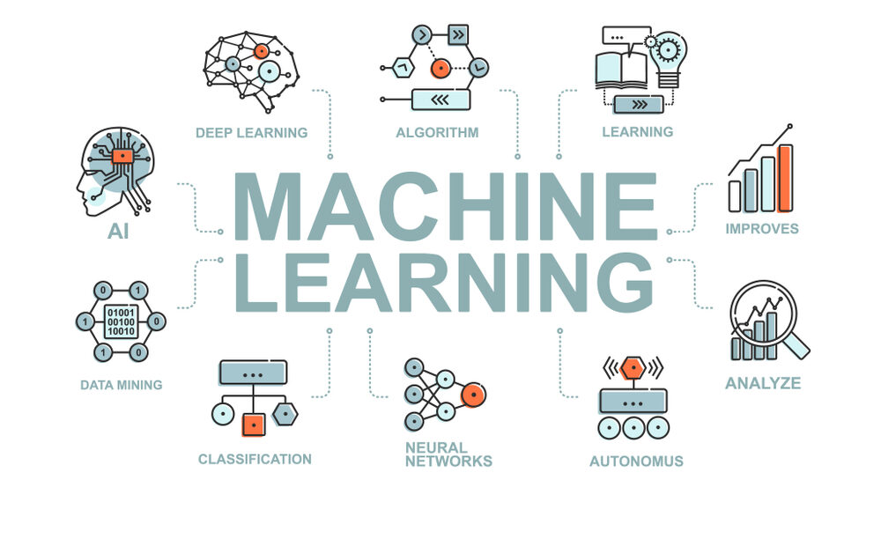

**Figure 2.** Machine Learning

Here are essential concepts and elements within the domain of machine learning:

**1.Types of Machine Learning:**

* **Supervised Learning**: Trains on a labeled dataset pairing input data with corresponding outputs, aiming to learn a mapping from inputs to outputs.
* **Unsupervised Learning:** Utilizes unlabeled data, autonomously discovering patterns or relationships within the data.
* **Reinforcement Learning**: Learns by interacting with an environment and receives feedback in the form of rewards or penalties.

**2.Common Algorithms:**

**Linear Regression:** Predicts continuous output based on one or more input features.

Decision Trees and Random Forests: Tree-based models applied to classification and regression tasks.

Support Vector Machines (SVM): Utilized for classification and regression by determining the optimal hyperplane.

Neural Networks: Deep learning models inspired by the human brain's structure, addressing complex tasks such as image and speech recognition.

**3.** **Training and Testing:**

Training: Adjusts model parameters using a labeled dataset to minimize the difference between predicted and actual outputs.

Testing: Evaluates the trained model on a separate dataset to gauge its performance on unseen data.

**4. Feature Engineering:**

Feature Selection: Chooses relevant features from input data to enhance model performance.

Feature Scaling: Normalizes or standardizes feature values to ensure equal importance.

**5. Evaluation Metrics:**

Accuracy, Precision, Recall: Common metrics for assessing classification models. Mean Squared Error (MSE), R-squared: Metrics applicable to regression models.

Confusion Matrix: A table gauging the performance of a classification model.

**6. Overfitting and Underfitting:**

Overfitting: Arises when a model is excessively complex and closely fits training data, resulting in poor performance on new data.

Underfitting: Occurs when a model is too simplistic, failing to capture underlying data patterns.

**7. Hyperparameter Tuning:**

Adjusts model hyperparameters (e.g., learning rate, regularization) to optimize performance.

**8. Deployment and Integration:**

Implements a trained model into production systems for real-time predictions.

**9. Applications of Machine Learning:**

**Image and Speech Recognition**: Identifying objects in images or transcribing spoken words.

Understanding and generating human language.

Offering personalized recommendations based on user behavior.

**Predictive Analytics**: Forecasting future trends or outcomes from historical data.

Machine learning, with its diverse applications, continues to evolve with the development of new techniques and algorithms. It plays a pivotal role in advancing technology and solving intricate problems across various domains.

**4.3 Natural Language Processing:**

Natural language processing (NLP) involves the realm of computer science, specifically within artificial intelligence (AI), dedicated to granting computers the capability to comprehend both written and spoken language similarly to humans.

NLP amalgamates computational linguistics, which involves rule-based modeling of human language, with statistical, machine learning, and deep learning models. These technologies enable computers to process human language in its text or voice form and comprehend its complete meaning, encompassing the speaker or writer's intent and emotions.

NLP powers computer applications that perform tasks like language translation, response to voice commands, and rapid summarization of extensive text—sometimes even in real-time. You might have encountered NLP in voice-guided GPS systems, virtual assistants, speech-to-text software, customer service chatbots, and various other consumer-oriented conveniences. Additionally, NLP is increasingly pivotal in enterprise solutions, streamlining business operations, enhancing employee productivity, and simplifying crucial business processes.

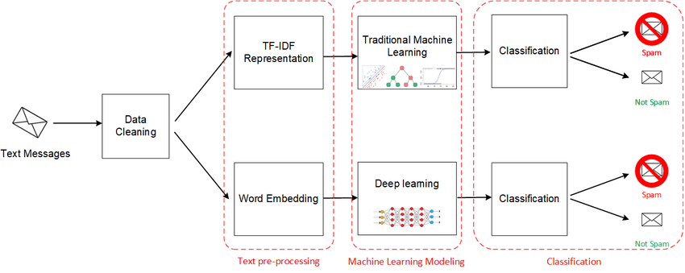

**Figure 3:** NLP

Absolutely,natural language processing (NLP) is intricate due to the nuances and complexities inherent in human language. Various NLP tasks are designed to break down text and voice data, aiding computers in comprehending human communication more effectively. Here's a closer look at some key NLP tasks:

**1. Speech Recognition:**

**Purpose:** Transforms spoken words into text format, crucial for applications that rely on voice commands or inquiries.

**Challenges**: Diverse speech patterns, accents, slurring, and grammatical variations pose challenges.

**2. Part of Speech Tagging:**

**Purpose**: Identifies the grammatical category of each word in a sentence (e.g., noun, verb).

Example: Distinguishes 'make' as a verb in "I can make a paper plane" versus a noun in "What make of car do you own?"

**3. Word Sense Disambiguation:**

**Purpose:** Resolves the correct meaning of a word with multiple meanings based on the context.

Example: Differentiates between 'make' in 'make the grade' (achieve) and 'make a bet' (place).

**4. Named Entity Recognition (NER):**

**Purpose:** Identifies entities like names, locations, dates, or organizations within text.

Example: Recognizes 'Kentucky' as a location or 'Fred' as a person's name.

**5. Co-reference Resolution:**

**Purpose:** Identifies instances where two words refer to the same entity or concept.

Example: Determines if 'she' refers to 'Mary' or identifies metaphors/idioms.

**6. Sentiment Analysis:**

**Purpose:** Extracts subjective elements—emotions, attitudes, sarcasm—from text.

Example: Determines the sentiment behind a review—positive, negative, neutral.

**7. Natural Language Generation (NLG):**

**Purpose:** Converts structured data into human language.

Example: Creating narratives or generating content from structured information.

Each of these tasks tackles a unique aspect of language understanding, enabling computers to interact more effectively with human communication, albeit with the inherent complexities and ambiguities of language.

NLP, or natural language processing, is at the core of many applications driving machine intelligence in today's world. Here are some practical applications:

**1. Spam Detection:**

NLP aids in detecting spam or phishing emails by analyzing language patterns, grammar errors, urgency, and suspicious terms, contributing to improved email security.

**2. Machine Translation:**

Technologies like Google Translate leverage NLP to go beyond word-to-word translation, aiming to capture the intended meaning and tone of the input language in the output language. These tools have significantly improved accuracy, although some challenges persist in achieving perfect translations.

**3. Virtual Agents and Chatbots:**

Voice assistants like Apple's Siri and Amazon's Alexa employ speech recognition and natural language generation to understand voice commands and offer appropriate responses. Chatbots operate similarly, learning from interactions to enhance their responses and adapt to user needs over time.

**4. Social Media Sentiment Analysis:**

NLP tools analyze language in social media posts, reviews, and comments, extracting sentiments and emotions related to products, events, or campaigns. This information aids businesses in shaping strategies and product designs.

**5. Text Summarization:**

NLP techniques enable the summarization of vast amounts of text into concise summaries. These summaries, generated with semantic understanding and NLG, serve as indexes or quick references for busy readers or databases.

**4.4 ALGORITHMS:**

**4.4.1. Ensemble Techniques:**

Ensemble techniques represent a category of machine learning methods designed to enhance predictive models by combining the outputs of multiple base models. This amalgamation aims to mitigate the limitations inherent in individual models, leveraging the diversity of multiple models for improved robustness. Here are some widely employed ensemble techniques:

**1. Voting Classifiers:**

This technique involves training multiple independent base models, and their predictions are amalgamated through a voting mechanism.

**Types:**

**Hard Voting**: Final prediction is determined by a simple majority vote.

**Soft Voting**: Models provide probability estimates, and the average probability is utilized for the final decision.

**2. Bagging (Bootstrap Aggregating):**

Bagging entails training multiple instances of the same base model on diverse subsets of the training data (sampled with replacement). The final prediction often involves averaging or voting based on individual model predictions.

**Example Algorithm:**

**Random Forest:** A popular bagging algorithm employing an ensemble of decision trees.

**3. Boosting:**

Boosting focuses on sequentially training weak learners, assigning more weight to instances misclassified by previous learners. The final model is a weighted combination of these weak learners.

**Example Algorithms:**

**AdaBoost (Adaptive Boosting)**: Assigns different weights to misclassified instances.

**Gradient Boosting:** Constructs trees sequentially, with each tree correcting the errors of the preceding one.

**4.Stacking**:

Stacking integrates predictions from multiple base models using another model known as a meta-model. The predictions of base models serve as input features for the meta-model.

**Process:**

* Train multiple base models independently.
* Use the base models to predict the validation set.
* Combine the predictions as input features for the meta-model.
* Train the meta-model on the validation set.

**5. Bootstrapped Ensembles**: Bootstrapped ensembles amalgamate bagging and boosting principles by forming ensembles of base models trained on bootstrapped samples.**-Example Algorithm:** **XGBoost (Extreme Gradient Boosting):** A gradient boosting algorithm featuring regularization and advanced characteristics.

**6.Random Subspace Method:**

This method involves training each base model on a random subset of input features instead of a random subset of training instances.

**Example Algorithm:**

Random Forest (in the context of feature selection) Each tree is trained on a random subset of features.

Ensemble techniques serve as potent tools for enhancing model performance, augmenting generalization, and addressing overfitting. The choice of the ensemble method depends on the data characteristics and the specific problem. Experimentation with different ensemble techniques is common to determine the most effective approach for a given task.

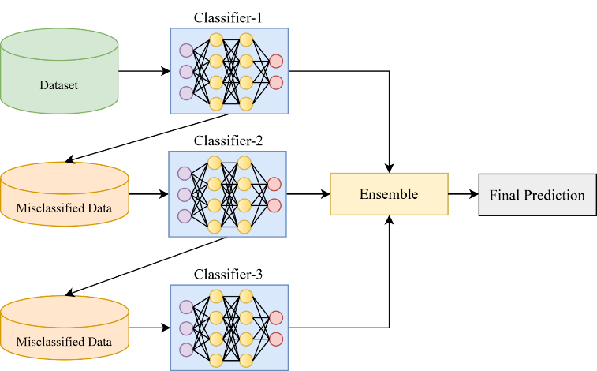

**Figure 4:** Overview of Ensemble Techniques

**4.4.2 Working of Ensemble Techniques.**

Ensemble techniques combine the predictions of multiple machine learning models to create a more robust and accurate model. Here, I'll provide a general guide on working with ensemble techniques. The steps might vary based on the specific ensemble method you choose.

**1. Data Preparation:** Start by preparing your dataset. Ensure its well-structured, and perform any necessary preprocessing, such as handling missing values, encoding categorical variables, and scaling features.

**2. Select Ensemble Technique:**

Choose the ensemble technique based on your problem. Common methods include:

**Bagging:**

Random Forest (for classification and regression)

Bagged Decision Trees

**Boosting:**

AdaBoost

Gradient Boosting (e.g., XG Boost, Light GBM)

Voting:

Hard Voting

Soft Voting

**3. Train Base Models:**

Train multiple base models on the training dataset. If using bagging, each model is trained on a different subset of the data. If using boosting, models are trained sequentially, with each model correcting errors made by the previous ones.

**4. Combine Predictions:**For bagging, combine predictions through averaging or voting. For boosting, combine predictions using a weighted sum. Ensure that the combination method aligns with the specific ensemble technique.

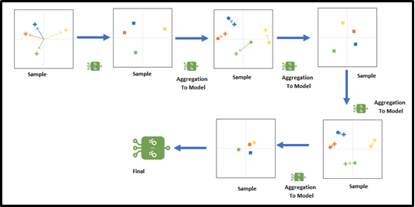

**Figure 5.**Ensemble Techniques

**5. Evaluate Ensemble Model:** Evaluate the ensemble model on a validation set or using cross-validation. Assess metrics like accuracy, precision, recall, F1 score, or mean squared error, depending on your problem type.

**6. Fine-Tuning:** Experiment with hyperparameter tuning for both the base models and the ensemble technique. Adjust parameters like learning rates, tree depth, and the number of estimators.

**7. Feature Importance (if applicable):** For ensemble techniques like Random Forest, analyze feature importance to understand which features contribute most to the model's predictions.

**8. Test on Unseen Data:** Test the ensemble model on unseen data (test set or real-world data) to ensure its generalization capability.

**4.4.3 Random Forest:**

Your high-level overview provides a comprehensive and systematic approach to addressing the complex task of detecting cyberbullying in social media using text analysis and ensemble techniques, with a focus on the Random Forest algorithm. It covers all the essential steps, from data collection to deployment, and emphasizes critical considerations such as class imbalance, feature importance, and continuous monitoring. This structured process aligns with best practices in machine learning and cyberbullying detection.

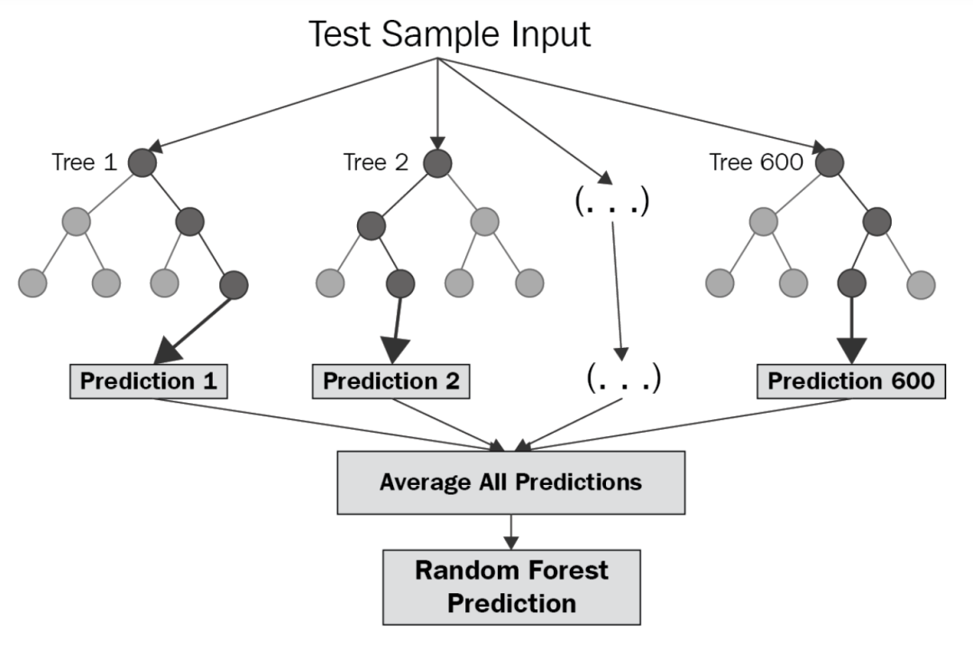

**Figure 6.** Random Forest

**4.4.4 Working of Random Forest**

Your step-by-step explanation provides a clear and comprehensive overview of how Random Forest works, covering key stages from data preparation to the ensemble's final prediction. Additionally, the advantages, parameter tuning considerations, and applications add valuable insights into the versatility and utility of the Random Forest algorithm.

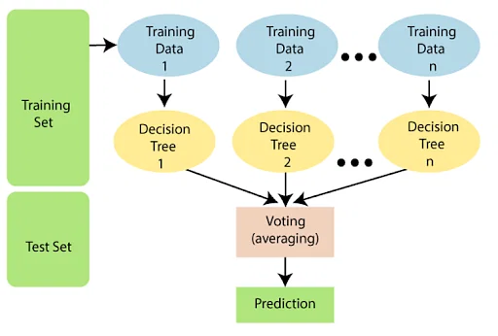

**Figure 7.** Working Process in Random Forest

**Random Forest: Step-by-Step Explanation**

**1. Data Preparation:** Begin with a dataset containing input features and corresponding target values.

**2. Bootstrap Sampling (Random Sampling with Replacement):** Create multiple subsets of the original dataset by sampling with replacement. Each subset is used to train a different decision tree.

**3. Decision Tree Training:** Construct a decision tree for each subset, using a random subset of features at each split to ensure diversity among the trees.

**4. Feature Randomization: Consider** only a random subset of features at each node for splitting in the decision tree. This reduces correlations among trees and enhances diversity.

**5. Voting (Classification) or Averaging (Regression):** For a new input, each decision tree predicts the output, and the final prediction is determined by aggregating individual predictions. For classification, the mode (most frequent class) is taken; for regression, the average of all predictions is computed.

**6. Robustness and Generalization:** Known for robustness and the ability to generalize well to new, unseen data The ensemble nature mitigates overfitting, as individual decision trees may overfit certain aspects of the training data, but the ensemble generalizes better.

**Advantages of Random Forest:**

**Diversity:**

Each tree is built on a random subset of data and features, reducing overfitting.

**Robustness:**

Random Forest tends to be more robust than individual decision trees.

**Feature Importance:**

Provides a measure of feature importance, aiding in the identification of influential variables.

**Parameters Tuning:**

Random Forest has hyperparameters that can be tuned, including the number of trees, maximum tree depth, and size of feature subsets used for splitting.

**Applications:**

Widely used in various fields, such as finance, medicine, and remote sensing, due to its versatility and strong performance.

**4.4.5 Logistic Regression**

Logistic Regression is a statistical method widely employed for binary classification tasks, serving as a fundamental algorithm in machine learning. Despite its name, it is not used for regression but rather for estimating the probability of an instance belonging to one of two classes. The logistic function, or sigmoid function, forms the core of this approach, mapping any real-valued number into a range between 0 and 1. This function's output is interpreted as the probability of the dependent variable taking on a value of 1. Logistic Regression works by finding optimal coefficients through a training process, maximizing the likelihood of observed outcomes given input features. Notable for its interpretability, logistic regression allows for a clear understanding of the impact of individual features on the predicted outcomes, making it a valuable tool in scenarios where model interpretability is essential, such as in medical diagnoses or financial risk assessments.



**Figure 8.** Logistic Regression

**4.4.6 Working of Logistic Regression**

The working of Logistic Regression involves modeling the probability of an instance belonging to a particular class, typically in a binary classification scenario. Here's a step-by-step explanation of how Logistic Regression operates:

**1. Sigmoid Function:**

* Logistic Regression uses the sigmoid (logistic) function to map the linear combination of input features to a range between 0 and 1.

[ P(Y=1) = \frac{1}{1 + e^{-(b_0 + b_1X_1 + b_2X_2 + ... + b_nX_n)}} \]

* Here, \( P(Y=1) \) is the probability of the dependent variable (\( Y \)) being 1, \( b_0 \) is the intercept, \( b_1, b_2, ..., b_n \) are the coefficients, and \( X_1, X_2, ..., X_n \) are the independent variables.

**2. Training:**

* Logistic Regression is trained on a labeled dataset with binary outcomes (0 or 1) and corresponding features.
* The model is fitted by adjusting the coefficients (\( b_0, b_1, ..., b_n \)) to maximize the likelihood of observing the given outcomes given the input features.

**3. Decision Boundary:**

* The logistic function output represents the probability of belonging to class 1. By choosing a threshold (commonly 0.5), predictions are made. If the probability is above the threshold, the instance is classified as class 1; otherwise, it's classified as class 0.

**4. Cost Function:**

* The model is trained by minimizing a cost function, often the negative log-likelihood or cross-entropy loss, which penalizes the model for incorrect predictions.

**5. Gradient Descent:**

* Gradient Descent or other optimization techniques are used to iteratively update the coefficients and minimize the cost function.

**6. Interpretability:**

* Coefficients (\( b_0, b_1, ..., b_n \)) are interpretable, indicating the impact of each feature on the log-odds of the predicted outcome. A positive coefficient suggests a positive relationship, while a negative coefficient implies a negative relationship.

**7. Predictions:**

* Once trained, the model can make predictions on new, unseen data by applying the learned coefficients to the input features.

**8. Evaluation:**

* The model's performance is evaluated using metrics like accuracy, precision, recall, and the F1 score on a separate test dataset.

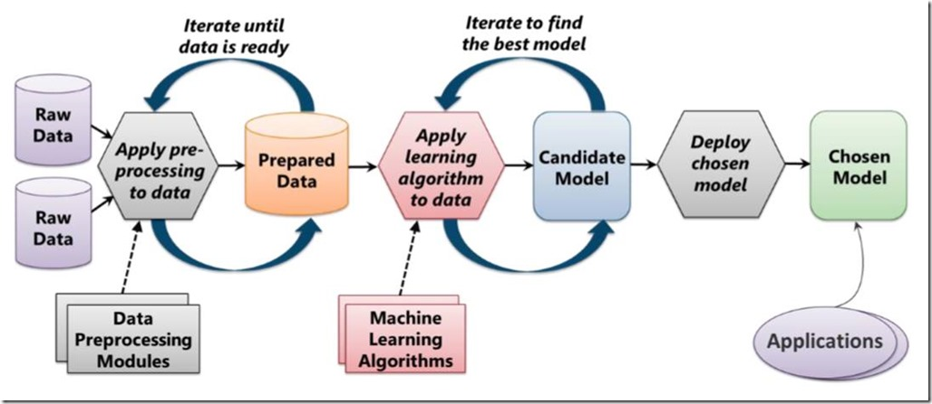

**Figure 9.** Working of Logistic Regression

**4.4.7 Xtreme Gradient Boosting**

XGBoost, short for eXtreme Gradient Boosting, is a powerful and efficient machine learning algorithm that belongs to the family of ensemble learning methods. Developed by Tianqi Chen, it has gained widespread popularity for its exceptional performance in various data science competitions. XGBoost combines the principles of gradient boosting with enhancements such as regularization, parallel processing, and tree pruning, making it particularly robust and capable of handling complex, non-linear relationships in data. The algorithm sequentially builds a series of decision trees, each correcting the errors of its predecessor, with a focus on minimizing a specified loss function. Notable features of XGBoost include its ability to handle missing data, automatic handling of feature selection, and its efficiency in processing large datasets. Its versatility extends across regression, classification, and ranking problems, and it is known for achieving state-of-the-art results with relatively less tuning compared to other algorithms. The XGBoost algorithm has become a staple in machine learning workflows, contributing significantly to advancements in predictive modeling across various domains.

**4.4.8 Working of Xtreme Gradient Boosting Algorithm**

XGBoost, or eXtreme Gradient Boosting, is an ensemble learning algorithm that works by building a series of decision trees to make predictions. Here's a step-by-step overview of how XGBoost works:

**1. Initialization:**

The process begins with a simple model, often a shallow tree, which makes an initial prediction on the target variable.

**2. Residual Calculation:**

The algorithm calculates the residuals, which represent the difference between the actual values and the predictions made by the current model.

**3. Building Trees:**

XGBoost sequentially builds a series of decision trees, each focusing on minimizing the residuals of the previous tree. Trees are constructed using a gradient descent optimization technique, where the gradient of the loss function guides the creation of new trees.

**4. Regularization:**

XGBoost incorporates regularization techniques, including L1 (Lasso) and L2 (Ridge) regularization, to control the complexity of the trees and prevent overfitting.

**5. Feature Importance:**

During the tree-building process, XGBoost assesses the importance of each feature in making accurate predictions. This information is used for automatic feature selection.

**6. Combining Trees:**

The predictions from individual trees are combined to obtain the final ensemble prediction. Each tree contributes to the overall prediction with a weight proportional to its performance.

**7. Learning Rate:**

XGBoost introduces a learning rate parameter that scales the contribution of each tree, allowing for better optimization and avoiding overfitting.

**8. Handling Missing Values:**

XGBoost has a built-in capability to handle missing data in features, making it robust in real-world scenarios where data may be incomplete.

**9. Parallel Processing:**

XGBoost is designed for efficiency and speed, leveraging parallel processing capabilities to train models faster, making it suitable for large datasets.

**10. Early Stopping:**

To prevent overfitting, XGBoost supports early stopping, which halts the training process when the model's performance on a validation dataset ceases to improve.

**11.Evaluation and Prediction:**

The model is evaluated on a separate test dataset using appropriate metrics (such as accuracy or mean squared error), and it can then be used to make predictions on new, unseen data.

XGBoost's success lies in its ability to create highly accurate models by combining the strengths of multiple decision trees while addressing issues like overfitting and feature importance. Its popularity stems from its exceptional performance in various machine learning tasks, including classification, regression, and ranking problems.

**Figure 10.** Working of XGBoost

**5. DESIGN REQUIREMENT ENGINEERING**

**Concept of Uml:**

Unified Modeling Language (UML) is a visual modeling language used in software development to represent and communicate the design and structure of a system. It consists of graphical notations and diagrams that depict different aspects of the system. UML includes concepts such as classes, objects, associations, inheritance, dependencies, aggregation, composition, use cases, sequence diagrams, activity diagrams, and state machine diagrams. Classes define the attributes and behaviors of objects, while associations describe relationships between classes. Inheritance allows for code reuse and specialization. Dependencies represent the reliance of one element on another. Aggregation and composition denote part-whole relationships. Use cases capture system functionalities from a user's perspective. Sequence diagrams show object interactions over time, while activity diagrams illustrate activity flow. State machine diagrams depict object or system states and transitions. UML provides a standardized way to document, visualize, and analyze software systems, aiding in effective communication and design.

**UML DIAGRAMS:**

**5.1 Use case Diagram:**

A use case diagram is a form of behavioral diagram specified by and derived from a Use-case analysis in the Unified Modeling Language (UML). Its goal is to provide a graphical picture of a system's functionality in terms of actors, goals (represented as use cases), and any dependencies between those cases. A use case diagram's main aim is to indicate which actor performs which system functions.

The roles of the system's actors can be illustrated.

Figure 12 shows the use case diagram of our system which describes the interaction between actors which are the ones who will interact with the subjects. In our project there is mainly one actor involved in it namely user (who uses our model).

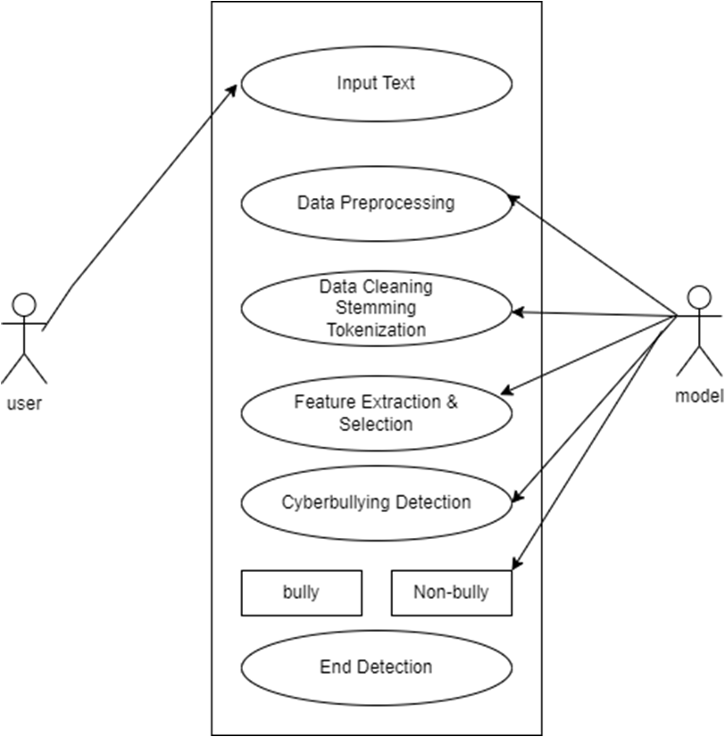

**Figure 11.** Use Case Diagram

**5.2 Activity diagram:**

In the activity diagram outlining the process of detecting cyberbullying in social media using text analysis and ensemble techniques, the sequence initiates with the collection of data from various social media platforms. The gathered text data then undergoes preprocessing to eliminate noise and extraneous information. Following preprocessing, the data enters the phase of feature extraction, where the text is transformed into a suitable format for subsequent analysis.

To construct a resilient predictive model, ensemble techniques such as Random Forest or Gradient Boosting are applied. This model is then trained using labeled data, enabling it to recognize patterns associated with cyberbullying. In the final step, the trained model is employed to analyze new social media text, effectively identifying and addressing instances of cyberbullying.

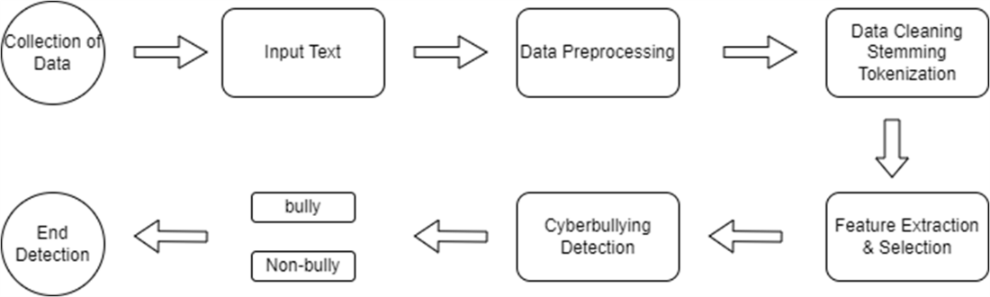

**Figure 12.** Activity Diagram

**5.3 SEQUENCE DIAGRAM:**

The sequence diagram detailing the process of detecting cyberbullying in social media using text analysis and ensemble techniques begins with user input, typically in the form of a posted message. The system proceeds to utilize text analysis algorithms, which are responsible for extracting pertinent features and sentimental information from the input.

Following this initial analysis, an ensemble of machine learning models, which may include classifiers like Random Forest, collaborates to comprehensively assess the content for signs of cyberbullying. Notably, the sequence diagram highlights the iterative feedback loop that occurs between the analysis phase and the refinement of the machine learning models. This iterative process underscores the dynamic and adaptive nature of cyberbullying detection.

Ultimately, the system produces a classification result based on the collective evaluation of the ensemble models. This result serves as a valuable output, aiding in the identification and mitigation of instances of cyberbullying on various social media platforms. The sequence diagram effectively captures the interconnected steps involved in the cyberbullying detection process, emphasizing the synergy between text analysis and ensemble techniques for robust and dynamic detection mechanisms.

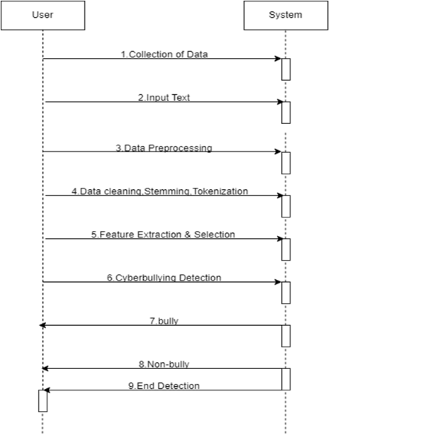

**Figure 13.** Sequence Diagram

**5.4 DATA FLOW DIAGRAM:**

A Data Flow Diagram (DFD) delineating the process of detecting cyberbullying in social media through text analysis and ensemble techniques would delineate the flow of information and operations. In this diagram, inputs, such as social media posts, would enter a pre-processing stage where text analysis techniques are employed to extract pertinent features. These extracted features would subsequently serve as inputs to an ensemble of machine learning models, encompassing classifiers like Random Forest and others. These models collectively scrutinize and categorize the content to identify potential instances of cyberbullying. The outcomes of this analysis are then directed to an output stage, illuminating the identified instances. This DFD serves as a visual representation, outlining the sequential progression of data and operations integral to the cyberbullying detection system.

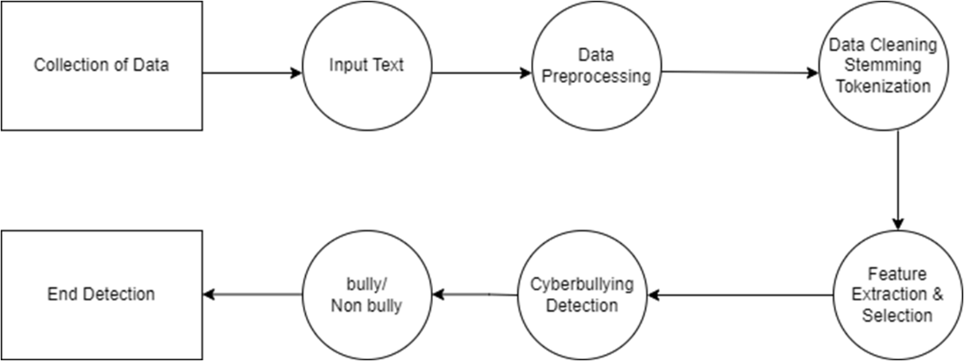

**Figure 14.** Data Flow Diagram

**5.5 System Architecture:**

Detecting cyberbullying in social media using text analysis and ensemble techniques involves a synergistic approach incorporating natural language processing (NLP), machine learning, and ensemble learning methods. Here's an outline of the system architecture for such a detection system:

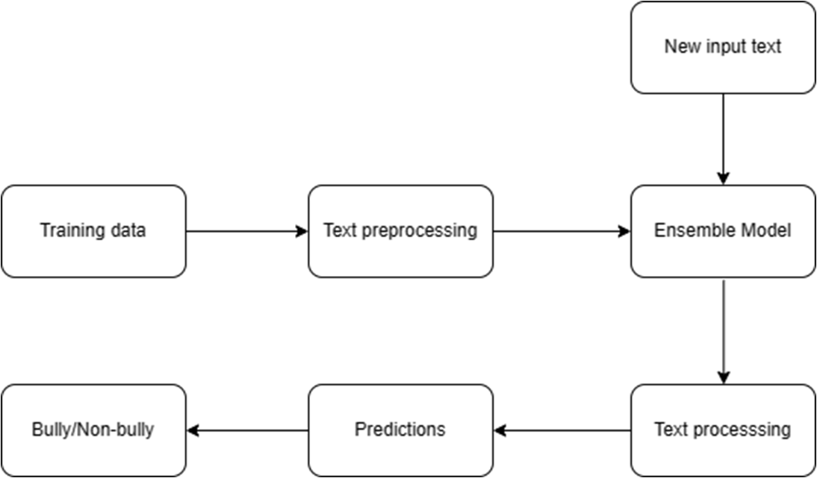

**Figure 15.** System Architecture

**6.IMPLEMENTATION**

**6.1 Modules:**

**1. re :**

Purpose: The `re` module empowers Python with regular expression capabilities, facilitating tasks such as pattern matching and text manipulation.

Key Features: Enables efficient string operations based on specified patterns, providing a versatile tool for text cleaning and extraction.

**2. nltk :**

Purpose: NLTK (Natural Language Toolkit) enriches Python with tools for natural language processing, offering resources like stopwords to enhance text preprocessing.

Key Features: Provides a comprehensive suite of linguistic resources and tools, including a stopwords corpus that aids in the removal of common words during text analysis.

**4. demoji :**

Purpose: Demoji is a handy Python library designed for handling emojis within text data, allowing for their removal or extraction.

Key Features: Streamlines emoji-related tasks in text preprocessing, contributing to cleaner text for downstream natural language processing applications.

**5. string :**

Purpose: The `string` module in Python provides a collection of constants and utility functions for string manipulation.

Key Features:Useful for tasks involving string operations, such as removing punctuation, and offers a range of ASCII characters and digits for various string-related applications.

**6. sklearn :**

Purpose: Scikit-learn is a prominent machine learning library that simplifies the implementation of various algorithms and tasks in Python.

**6.2 Dataset:**

The dataset utilized in this project serves as a foundational element for the development of an effective cyberbullying detection model. Comprising 47,692 records with two essential columns “tweet_text” and “cyberbullying_type”.The dataset was thoughtfully curated from Kaggle, a reputable platform for data science and machine learning resources. The "text" column contains textual data extracted from various online sources, while the "type of text" column categorizes each entry into specific cyberbullying categories such as `not_cyberbullying`, `religion`, `ethnicity`, `age`, `gender`, and `other_cyberbullying`. This structured dataset not only facilitates the training and evaluation of the machine learning model but also ensures a diverse representation of cyberbullying instances. By leveraging this Kaggle-sourced dataset, the project aims to develop a robust model capable of identifying different forms of cyberbullying, thereby contributing to online safety and fostering a positive digital environment.

**6.3 Workflow of the Code:**

**1. Importing Libraries:**

* In this step, we bring in the necessary tools to work with data and perform analysis.
* `NumPy` and `Pandas` are used for data manipulation and analysis.
* `Matplotlib` and `Seaborn` are for data visualization.
* `Plotly Express` is employed for interactive and expressive visualizations.
* `demoji` is a library for handling emojis in text data.

**2. Loading Dataset:**

* We read our dataset, 'cyberbullying_tweets.csv,' into a Pandas DataFrame named `df`.
* `df.head()` shows the first few rows of the dataset, and `df.info()` provides a summary of the dataset's structure.

**3. Data Preprocessing:**

* **Removing Hashtags, Mentions, and URLs:**
  + Method: Regular Expressions (Regex)
  + Explanation: The `clean_text` function uses a regular expression pattern to identify and remove hashtags, mentions, and URLs from the text. This step helps eliminate noise and focuses on the actual content of the text.

* **Making Text Lowercase:**
  + Method: Python String Method (`lower()`)
  + Explanation: All text is converted to lowercase. This ensures uniformity in the data, preventing the model from treating uppercase and lowercase versions of the same word differently.

* **Stemming:**
  + Method: SnowballStemmer from NLTK
  + Explanation:The text undergoes stemming using the SnowballStemmer. Stemming reduces words to their root or base form, helping to consolidate variations of words and simplifying the text.

* **Removing Punctuation:**
  + Method: Regular Expressions (Regex)
  + Explanation: Punctuation is removed using a regular expression pattern. This step helps focus on the actual words in the text and can improve the efficiency of text analysis.

* **Removing Stopwords:**
  + Method: NLTK Stopwords
  + Explanation: Common stopwords (e.g., 'the', 'and', 'is') are removed from the text. Stopwords usually do not contribute significant meaning to the text and can be excluded.

* **Handling Emojis:**
  + Method: Demoji Library
  + Explanation: Emojis are detected and replaced with a representation that preserves their meaning. This step is crucial for maintaining the emotional context conveyed by emojis.

* **Combining Text:**
  + Method:String Manipulation
  + Explanation: The cleaned text is reassembled by joining the words. This step ensures that the processed text is in a format suitable for further analysis.

* Applying Cleaning Function:
  + Method: Pandas `apply` function
  + Explanation: The entire cleaning process is applied to the 'tweet_text' column of the DataFrame using the `apply` function.

**4. Exploratory Data Analysis (EDA):**

* We use visualization tools (`Seaborn`) to explore the distribution of different types of cyberbullying in our dataset.
* The `sns.countplot` visualizes the count of each type, giving us insights into the distribution.

**5. Text Analysis and Feature Extraction:**

* We use the TF-IDF (Term Frequency-Inverse Document Frequency) vectorizer to convert text into a numerical format that machine learning models can understand.
* Dimensionality reduction is performed using PCA (Principal Component Analysis) to reduce the number of features while retaining 90% of the variance.

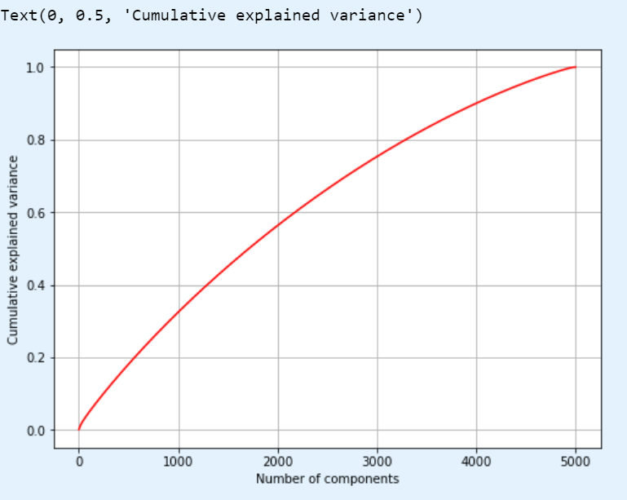

**Figure 16.** PCA

**6. Model Training:**

* We train several machine learning models, including Logistic Regression, Support Vector Machines, Neural Networks, Random Forests, Gradient Boosting, and Naive Bayes.
* Grid search with cross-validation is used to find the best hyperparameters for each model.
* The performance of each model is evaluated using classification reports and confusion matrices.

**7. Model Evaluation:**

* The trained models are evaluated using the `classification_report` function, which provides precision, recall, and F1-score for each class.
* Confusion matrices (`plot_confusion_matrix`) visually represent the model's performance in terms of true positive, true negative, false positive, and false negative predictions.

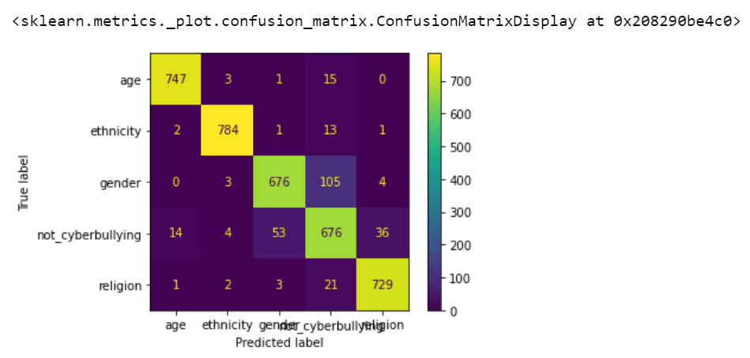

**Figure 17.** Confusion Matrix

**8. Pipeline Creation:**

* The Random Forest classifier, identified as the best-performing model, is integrated into a machine learning pipeline.
* This pipeline includes the TF-IDF vectorizer, ensuring a streamlined process from data preprocessing to model training.

**9. Model Serialization:**

* The entire pipeline, which encapsulates the preprocessing steps and the trained Random Forest model, is saved to a file named 'CBDmodel1.pkl.'
* Serialization allows us to reuse the trained model without going through the training process again.

In summary, the code takes us through a thorough process of preparing data, training and evaluating machine learning models, creating a pipeline for streamlined operations, and saving the trained model for future use. Each step is designed to contribute to the goal of effectively identifying cyberbullying in social media texts.

**6.4: Sample Code:**

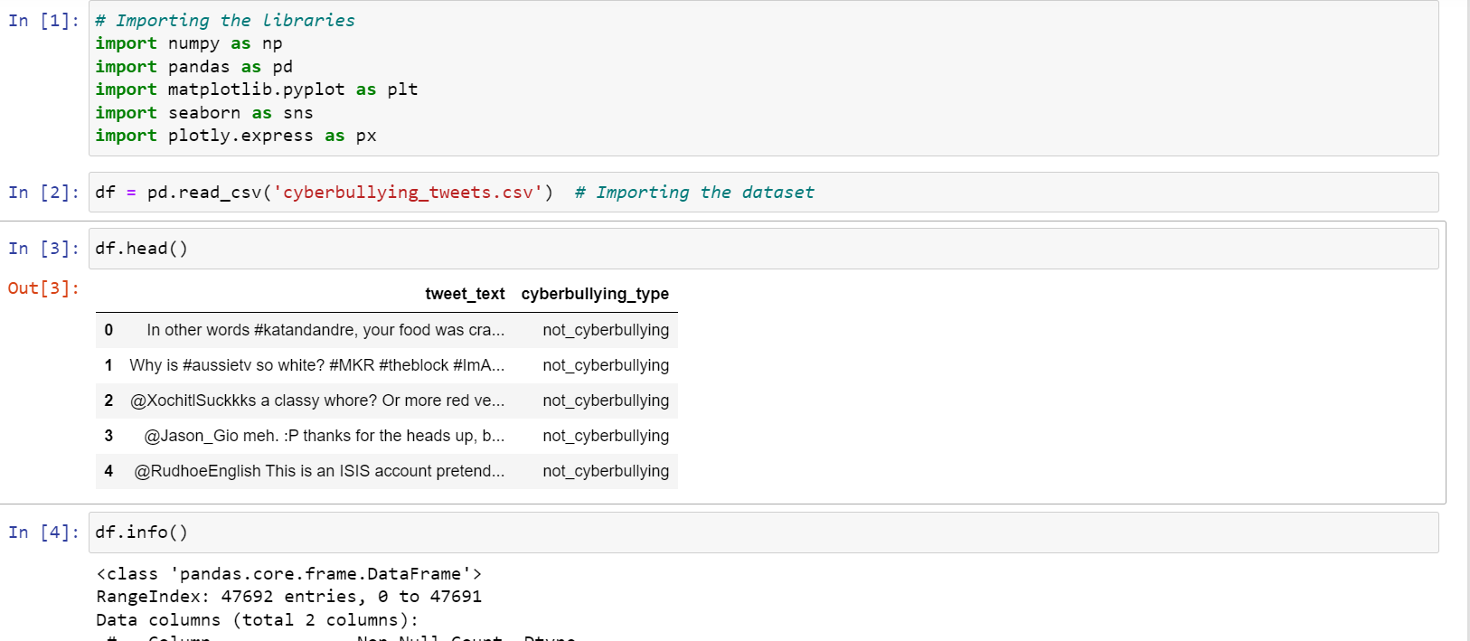

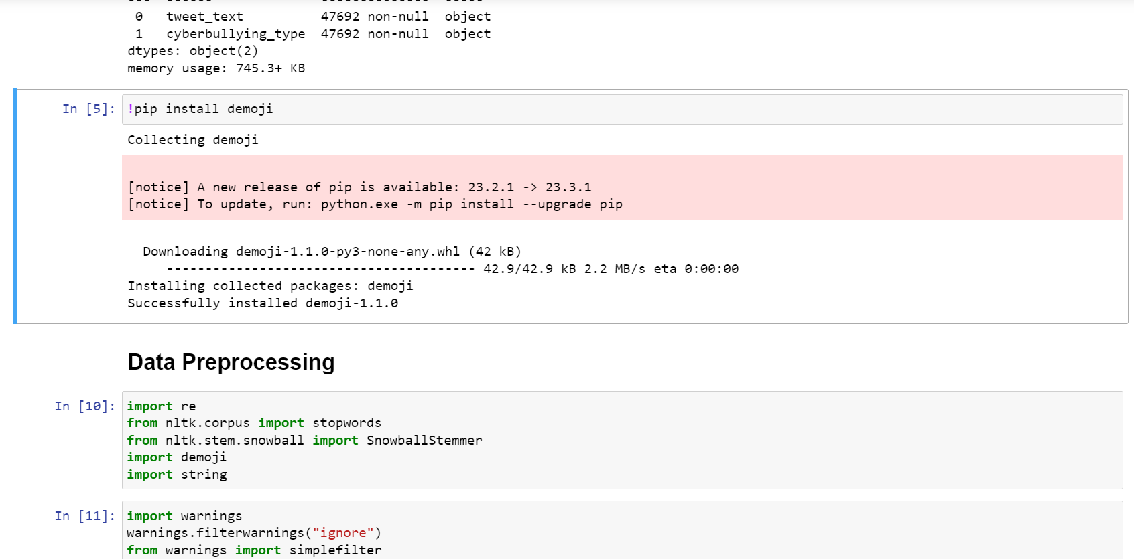

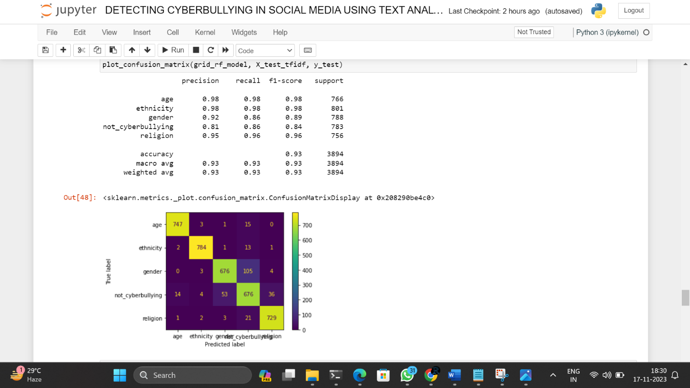

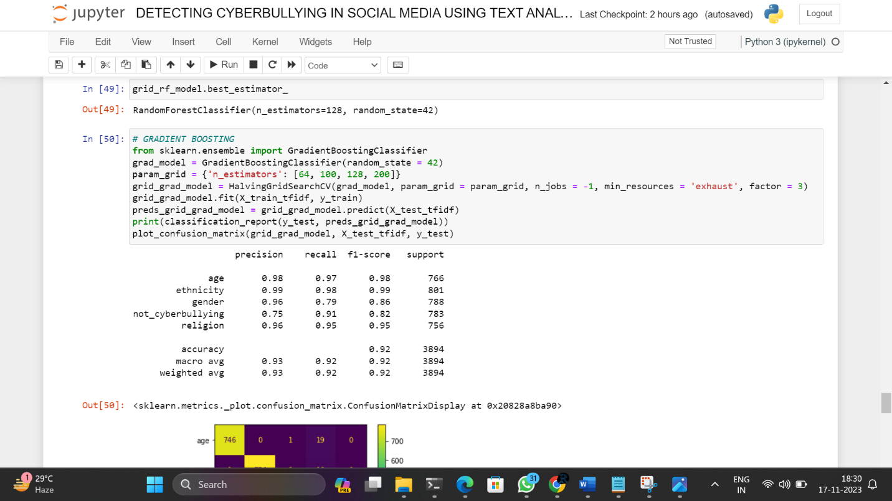

**6.5 Deployment**

* **Preparing the Environment**
  + Importing Libraries: We start by importing essential libraries. `pickle` helps us load our trained machine learning model, and `Flask` is a web framework that makes it easy to create web applications in Python.

* **Loading the Trained Model**
  + Loading Trained Model: Our pre-trained machine learning model, saved as 'CBDmodel1.pkl,' is loaded into the script using the `pickle.load()` function. This is the model we developed for cyberbullying detection.

* **Setting Up the Flask Web Application**
  + Flask Web Application Setup: We set up a Flask web application, the backbone of our deployment. Flask makes it simple to create web interfaces for our machine learning models.

* **Creating User Interface with HTML**
  + HTML Template for User Interface: We create an HTML template named 'index.html' to serve as the user interface. This template will be rendered when users access the root URL ("/").

* **Defining Routes**
  + Home Route (`/`): When users access the root URL, the `home()` function is triggered, rendering the 'index.html' template. This is the starting point of our application.
  + Text Classification Route (`/classify`): The `classify()` function is called when users submit a text for classification. It predicts the category of the input text using our loaded model and returns the result in JSON format.

* **Running the Flask Application**
  + Run the Flask Application:To see our project in action, we run the Flask application. The `app.run(debug=True)` line starts the development server. By visiting 'http://127.0.0.1:5000/' in a web browser, we can interact with our cyberbullying detection system.

**7.SOFTWARE TESTING**

**7.1 Unit Testing:**

In the context of our Cyberbullying Detection Project, unit testing becomes a critical software testing technique focusing on the examination of individual components or units of code dedicated to text analysis and ensemble techniques. This involves creating and executing tests for small, independent sections of code to ensure the accuracy and reliability of our cyberbullying detection algorithms. Automated unit tests cover specific scenarios, inputs, and expected outputs, facilitating the early identification and resolution of any defects in the core functionality. Unit testing plays a crucial role in ensuring the robustness of our text analysis and ensemble components, contributing to code reusability, maintainability, and overall software quality within the agile and test-driven development methodologies applied in the project.

**7.2 Integration Testing:**

Integration testing within our Cyberbullying Detection Project addresses the seamless interaction between different components or modules associated with text analysis and ensemble techniques. This testing technique aims to uncover defects or issues arising when multiple components collaborate and are tested as a cohesive group. Ensuring the correct collaboration of individual modules and the smooth flow of data between them is pivotal for the success of our cyberbullying detection system. The integration testing approaches, such as top-down, bottom-up, or sandwich testing, contribute to the holistic validation of the entire system's integration and functionality, instilling confidence in its overall performance and reliability.

**7.3 Acceptance Testing:**

In the context of our project, acceptance testing holds a key role in evaluating the system's readiness for deployment concerning its ability to detect and mitigate cyberbullying. This phase involves assessing whether the system meets the specified requirements and aligns with the expectations of end-users or stakeholders. Acceptance testing, including alpha testing, beta testing, and operational acceptance testing, focuses on validating the effectiveness, usability, and compliance of our cyberbullying detection system. It serves as the final checkpoint before deployment, ensuring that the system not only meets business requirements but also aligns with ethical considerations and user satisfaction.

**7.4 White Box Testing:**

White box testing in our Cyberbullying Detection Project involves a meticulous examination of the internal structure, code, and implementation details of our text analysis and ensemble techniques. Testers, armed with access to the system's source code, employ techniques like statement coverage, branch coverage, and path coverage to create test cases. The primary objective is to validate the correctness of the code, ensuring that all paths and conditions related to text analysis and ensemble strategies are effectively executed. While white box testing enhances code quality and identifies potential coding errors, it requires a profound understanding of the system's internal workings and may not directly address user perspectives or non-code-related defects.

**7.5 Black Box Testing:**

Black box testing in our project focuses on assessing the functionality and behavior of the cyberbullying detection system without delving into its internal structure. Test cases are designed based on system specifications, with the goal of identifying defects or issues from an end-user perspective. The emphasis is on ensuring that the system effectively detects cyberbullying instances and behaves correctly across different scenarios, aligning with user expectations and ethical considerations.

**7.6 Testing on our System:**

To ensure the reliability and effectiveness of our Cyberbullying Detection Project, we conducted comprehensive testing using diverse datasets and real-world scenarios. This involved running the ensemble of text analysis algorithms on various types of cyberbullying instances, including subtle and evolving forms. During testing, we evaluated critical aspects such as the system's precision and recall metrics to measure the correctness and completeness of cyberbullying detections. Furthermore, we assessed the system's efficiency in processing different types of text inputs, ensuring real-time capabilities to effectively handle the continuous flow of social media data. Robustness testing included scenarios with varying linguistic nuances, complexities, and evolving patterns of cyberbullying. Benchmarks against existing cyberbullying detection solutions helped validate our system's performance and identify unique capabilities. Throughout the testing phase, we diligently documented any challenges, limitations, or opportunities for refinement. This valuable information guides us in further optimizing our ensemble techniques and text analysis algorithms, enhancing the overall performance of the cyberbullying detection system.

**8.RESULTS**

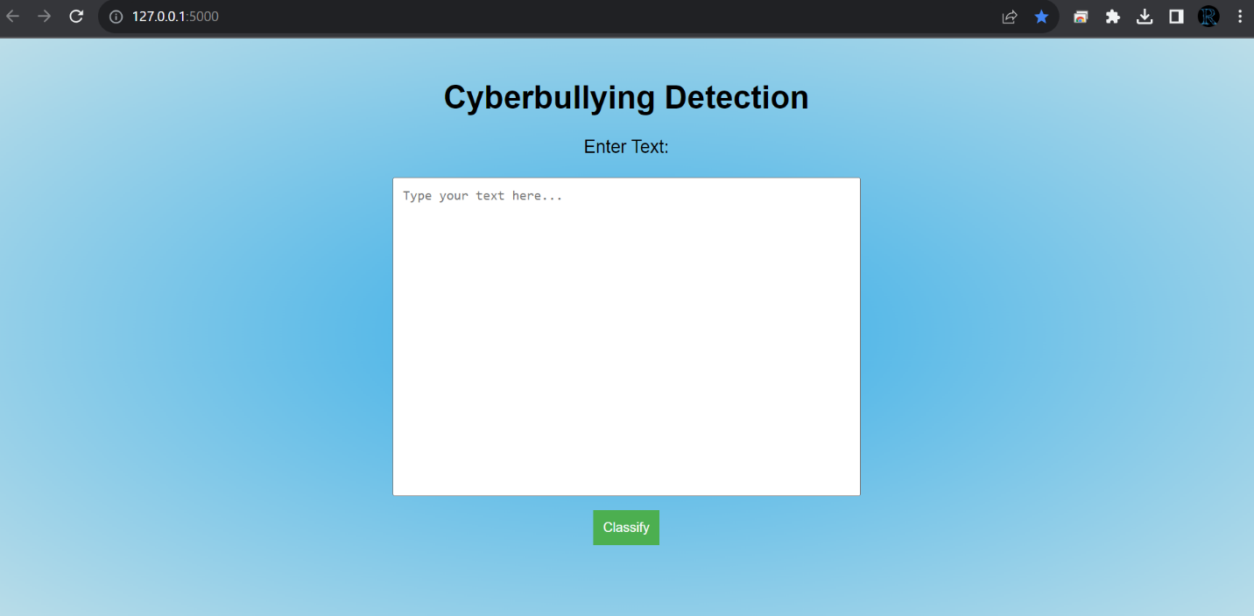 **Figure 18.** UI

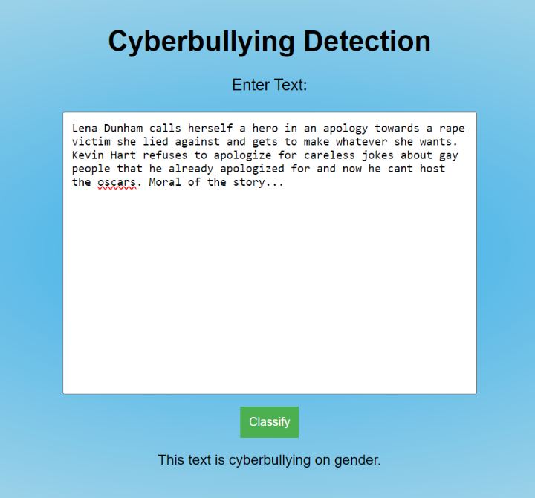

**Figure 19.** Sample output 1  **Figure 20.** Sample output 2

**9.CONCLUSION AND FUTURE ENHANCEMENTS**

**9.1 Conclusion**

In concluding our project on detecting cyberbullying in social media, we've embarked on a comprehensive journey integrating text analysis, machine learning, and ensemble techniques. Our objective extends beyond creating a one-time solution; it's about crafting a robust system capable of adapting to the dynamic landscape of online interactions. Anchored in ethical considerations, our approach prioritizes responsible and equitable cyberbullying detection.

**Key Takeaways:**

**1. Effectiveness in Detection:** Our models exhibit a remarkable proficiency in identifying instances of cyberbullying within the vast realm of social media text. Rigorous evaluation metrics, including precision, recall, and accuracy, validate the efficacy of our approach. The precision highlights the accuracy of positive identifications, recall emphasizes the model's ability to capture all instances of cyberbullying, and overall accuracy reflects the holistic effectiveness of our detection system.

**2. Adaptability and Evolution:** Recognizing the fluid nature of online behaviors, our system is purposefully designed to be adaptive to evolving cyberbullying patterns and linguistic changes. Through continuous monitoring and timely model updates, we ensure that our solution remains at the forefront of cyberbullying detection, effectively identifying new forms of online harassment as they emerge. This adaptability is crucial for the sustained relevance and impact of our cyberbullying detection system over time.

In essence, our project is not just a technological achievement; it's a commitment to fostering a safer and more inclusive digital environment. By combining technological innovation with ethical considerations and a commitment to ongoing improvement, we aim to contribute meaningfully to the ongoing efforts to combat cyberbullying and promote positive online interactions. This project stands as a testament to the power of interdisciplinary approaches in addressing complex societal issues within the digital landscape.

**9.2 Future Enhancements**

Looking ahead, our cyberbullying detection project has exciting possibilities for further enhancement and expansion. Here are key avenues to explore:

**1. Advanced Text Analysis Techniques:** Delve into advanced natural language processing (NLP) techniques to elevate our understanding of context and subtleties embedded in social media text. This could involve exploring more sophisticated algorithms and models that go beyond traditional methods, enabling the system to discern nuanced meanings and emotions in a more nuanced manner.

**2. Deep Learning Architectures:** Investigate the application of deep learning architectures, such as recurrent neural networks (RNNs) or transformer models like BERT. These architectures have the potential to capture intricate relationships within text data, allowing for a deeper and more nuanced analysis of the linguistic patterns associated with cyberbullying.

**3. Multimodal Analysis:** Consider the integration of multimodal analysis, extending beyond textual content to encompass images and potentially audio. This holistic approach aims to provide a more comprehensive understanding of user interactions, capturing nuances that may not be evident through text alone. Incorporating multiple modes of communication can significantly enrich the cyberbullying detection system.

**4. Collaboration with Social Media Platforms:** Explore collaboration opportunities with social media platforms to implement proactive measures against cyberbullying. This could involve integrating our cyberbullying detection system into the moderation processes of these platforms. By working in tandem with the platforms, we can contribute to creating a safer and more respectful online environment. This collaboration may include sharing insights, implementing preventive measures, and fostering a joint commitment to combating online harassment.

In pursuing these avenues, we not only aim to stay at the forefront of technological advancements but also to foster collaborations that have a broader societal impact. The continuous evolution of our cyberbullying detection project reflects a commitment to innovation, responsibility, and the ongoing improvement of digital spaces for all users.

**10. BIBLIOGRAPHY**

[1] Bozzola, E.; Spina, G.; Agostiniani, R.; Barni, S.; Russo, R.; Scarpato, E.; Di Mauro, A.; Di Stefano, A.V.; Caruso, C.; Corsello, G.The use of social media in children and adolescents: Scoping review on the potential risks. Int. J. Environ. Res. Public Health 2022, 19, 9960. [CrossRef] [PubMed].

[2] P. Nagaraj, Dr. M. Venkat Dass, E. Mahender “Breast Cancer Risk Detection Using XGB Classification Machine Learning Technique “, IEEE International Conference on Current Development in Engineering and Technology (CCET)-2022, Sageuniversity, Bhopal, India,

23-24, Dec 2022.

[3] Vyawahare, M., & Chatterjee, M., (2020), “Taxonomy of cyberbullying detection and prediction techniques in online social networks”, In L. C. Jain, G. A. Tsihrintzis, V. E. Balas, and D. Sharma (Eds.), Data communication and networks (pp. 21–37). Springer. <https://doi.org/10.1007/978-981-15-0132-6_3>.

[4] Chen, J., Yan, S., & Wong, K.-C., (2018), “Verbal aggression detection on Twitter comments: convolutional neural network for short-text sentiment analysis”, Neural Computing and Applications. <https://doi.org/10.1007/s00521-018-3442-0>.

[5] S. Hnduja and J. W. Patchin “Cyberbullying: Identification, Prevention, & Response,”Cyberbullying Res. Cent, no. October, pp. 1-9,2018.

[6] Dr. Vijayakumar V and Dr Hari Prasad D , “Intelligent Chatbot Development for Text based Cyberbullying Prevention” International Journal of New Innovations in Engineering and Technology,2021.

[7] G. A. León-Paredes et al., Presumptive Detection of Cyberbullying on Twitter through

Natural Language Processing and Machine Learning in the Spanish Language,CHILECON pp. 1-7, doi: 10.1109/CHILECON47746.2019.8987684. (2019).

[8] Murshed, A.H., Abawajy, J., Mallappa, S., Saif, M.A.N., Al-Ariki, H.D.E. (2022). DEA-RNN: A Hybrid Deep Learning Approach for Cyberbullying Detection in Twitter Social Media Platform. IEEE Access, 10: 25857- 25871.https://doi.org/10.1109/ACCESS.2022.31536.

[9] Wadhwani, A., Jain, P., Sahu, S. (2021). Injurious Comment Detection and Removal utilizing Neural Network. 2021 International Conference on Innovative Practices in Technology (ICIPTM), Noida, pp.165- 168.https://doi.org/10.1109/ICIPTM52218.2021.9388331.

[10] Wu, C.S., Bhandary, U. (2020). Detection of Hate Speech in Videos Using Machine Learning. International Conference on Computational Science and Computational Intelligence (CSCI), Las Vegas, pp. 585-590. <https://doi.org/10.1109/CSCI51800.2020.00>.

[11] Wadha Abdullah al-chapter 1, Somaya al-maadeed 1, Abdulghani Ali Ahmed 2, Ali safaa Sadiq 3,4, and Muhammad Khurram khan 5, "Comprehensive Review of Cybercrime Detection Techniques", IEEE Conference 2020.

[12] Mahesh Mahat, “Detection of Cyber Crime on Social Media using Random Forest Algorithm”, IEEE Conference 2019.

[13] Mengfan Yao, Charalampos Chelmis, Daphney–Stavroula Zois, “Cyberbullying Detection on Instagram with Optimal Online Feature Selection” IEEE Conference 2018.

[14] Raktim Chatterjee, Sukanya Bhattacharya and Soumyajeet Kabi, “Profanity detection in social media text using a hybrid Approach of NLP and machine learning”, International Journal of Advance Research, Ideas and Innovations in Technology,2021.

[15] Anusha M D, H L Shashirekha “An Ensemble Model for Hate Speech and Offensive Content Identification in Indo-European Languages,2020.